Maths (Miss Brazil’s group)
Week 1
- Revise finding missing lengths to calculate the perimeter of a composite rectilinear shape.
- Find the missing lengths in a compound rectilinear shape to calculate its area
- Revise names of 2D and 3D shapes
- Estimate the capacity/volume of a 3D shape

Task:
You work for a carpet fitting company and you have some customers have given you floor plans.
The rooms need new carpet and skirting board.
Find the area of the rooms and price up the carpet; find the perimeter and price up the skirting board.

The price of carpet and skirting board is as follows:

Flooring | Cost per m² | Flooring | Cost per m
Basic Carpet suitable for low wear and tear | £4.50 | Basic Skirting board suitable for low wear and tear | £4.99
Luxury Carpet suitable for high wear and tear | £12.25 | Luxury Skirting board suitable for high wear and tear | £9.85

Mrs. Harris

Mrs. Smithson

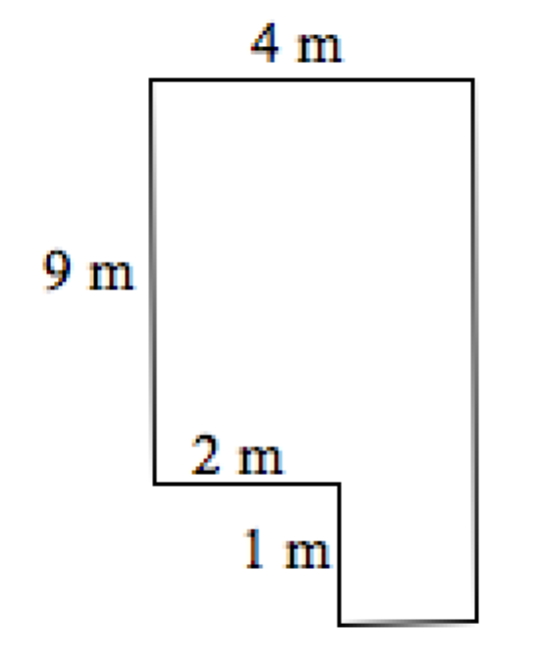
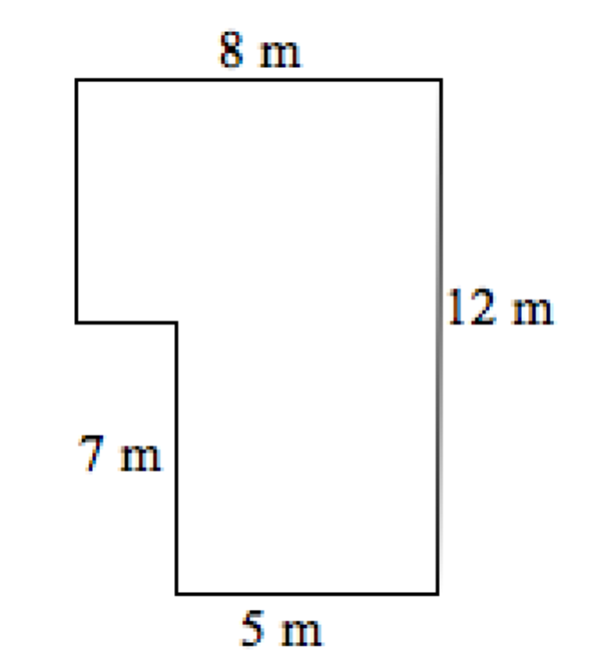
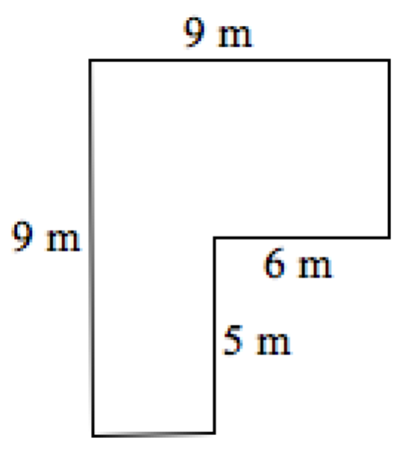
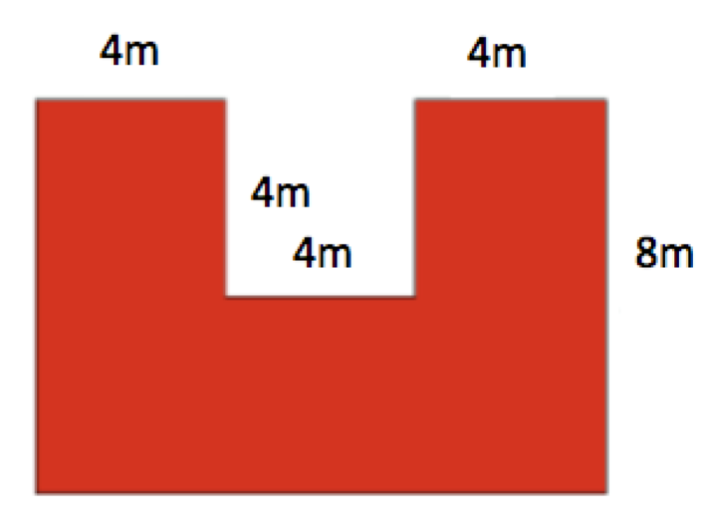

Mr. Langdon

Mrs. Pounder

Week 2
- Revise column methods for addition, subtraction and multiplication
- Revise bus stop method for division
- Revise understanding of fractions and decimals
- Revise understanding of percentages (and how they link to fractions and decimals) including how to find percentages of amounts.

Task:

Round each of these numbers to one decimal place.
3.62 4.78 2.84 5.75

6.938 4.07 9.132 8.05

8.97 3.029 9.971 0.46

0.92 0.99 0.08 0.028

Task 2:
Find 30% of:

- 30% of 30 = 4. 30% of 20 =
- 30% of 90 = 5. 30% of 100 =
- 30% of 60 = 6. 30% of 70 =

Now find 5% of:

- 5% of 30 = 4. 5% of 20 =
- 5% of 90 = 5. 5% of 100 =
- 5% of 60 = 6. 5% of 70 =

Finally find 15% of:

- 15% of 30 = 4. 15% of 20 =
- 15% of 90 = 5. 15% of 100 =
- 15% of 60 = 6. 15% of 70 =
Task 3:
- Would you rather...? of £4 of £8 of £6
- Would you rather...? of £8 of £4 of £9
- Would you rather...? of £36 of £36 of £55
- Would you rather...? of £35 of £96 of £30
- Would you rather...? of £25 of £27 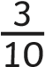 of £60
- Would you rather...? of £48 of £44 of £45
- Would you rather...? of £54 of £49 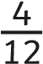 of £60

